Seychelles Natural History Museum Registration form 2023

REGISTRATION FORM  NATIONAL MUSEUM CLUB: NATURAL HISTORY MUSEUM  FOR PARTICIPANTS AGED 7-16 YEARS  INDEPENDENCE AVENUE  TEL: +248 2822326 + 248 2514606  EMAIL: nbarreau@gov.sc  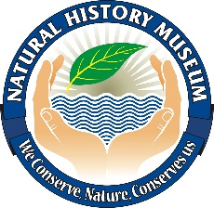 | Photo

Name

Surname
Date of Birth
Nationality

Address

NIN
Gender
Name of School

Class

Name of Parent

Contact of parent

CONTACT NUMBER & PERSON IN
CASE OF EMERGENCY

I____________________________________ (parent /Guardian) do give my consent to my (Son/daughter) ________________________________ to participate in the National Museum Club: Natural History Museum

Parent /Guardian signature: _________________________ Date: _____________

